Packet Tracer – Configuring Port Forwarding on a Wireless Router

1. Topology

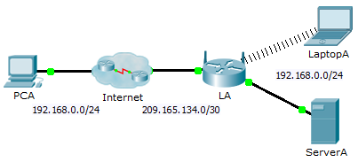

Addressing Table

|  |  |  |  |
| --- | --- | --- | --- |
| Device | Interface | IP Address | Subnet Mask |
| LA | Internet | 209.165.134.1 | 255.255.255.252 |
| LAN | 192.168.0.1 | 255.255.255.0 |

1. Objectives

Part 1: Configure Port Forwarding

Part 2: Verify Remote Connectivity to ServerA

1. Scenario

Your friend wants to play a game with you on your server. Both of you are at your respective homes, connected to the Internet. You need to configure your SOHO (Small Office, Home Office) router to port forward HTTP requests to your server so that your friend can access the game lobby web page.

1. Configure Port Forwarding
   * 1. From the web browser on **LaptopA**, access **LA** by entering the LAN IP address, 192.168.0.1. The username is **admin** and the password is **cisco123**.
     2. Click **Applications & Gaming**. In the first dropdown on the left, choose **HTTP** and then enter 192.168.0.2 in the “To IP Address” column. This configures **LA** to forward port 80 to 192.168.0.2. Check the **Enabled** box next to the address column.
     3. Scroll to the bottom and click **Save Settings**.
2. Verify Remote Connectivity to ServerA

From the web browser on **PCA**, enter the Internet IP address for **LA**. The game server web page should appear.